

**IT0043 FINAL PROJECT**

Web Design Fundamentals with Client-Side Scripting

SUBMITTED BY:

*(Surname, First Name)*

*Abuan, Faith*

*Coronel, Yvan*

*Lee, Bea Glennel B.*

*Lopez, Katherine Mega F.*

*BSITSMBA-B23*

SUBMITTED TO:

Mr. John Heland Jasper C. Ortega

* *Note: Please remove all the red texts and change it to standard format,*

*(Calibri 12 black, Double spacing) it will only serve as your guideline. Pls. print for checking*

*November 11, 2019*

1. 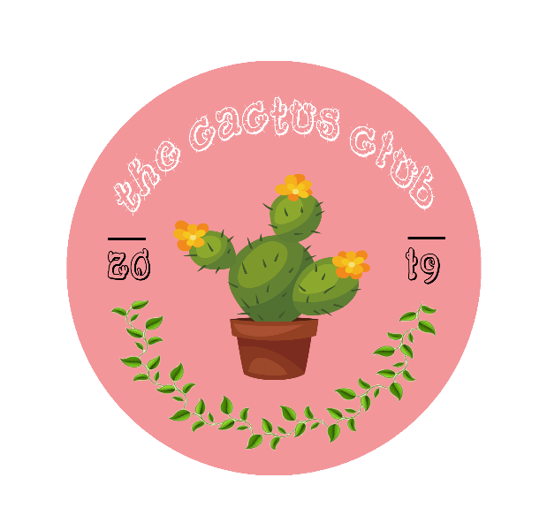LOGO

The logo represents the identification of The Cactus Club website. A logo is very important so that the customer will be able to immediately identify The Cactus Club website when they see it. The main highlight of the logo is the cactus because the group's e-commerce website sells different kinds of cactus plants. The logo also has the website name and that is The Cactus Club, 2019 that means the year it was made, and leaves which symbolizes life and growth.

1. WEBSITE DESCRIPTION *(at least 5 sentences*)
2. THEME *(Dark or Light, explain why you choose this particular theme*)
3. DESIGNS
4. Color Palette *(maximum of 3 colors, include screenshots + hex code)*
5. Typography *(fonts used in the ‘Title’, ‘Secondary Text’ and ‘Text Content’ of*

*your website. Add screenshots and indicate font style)*

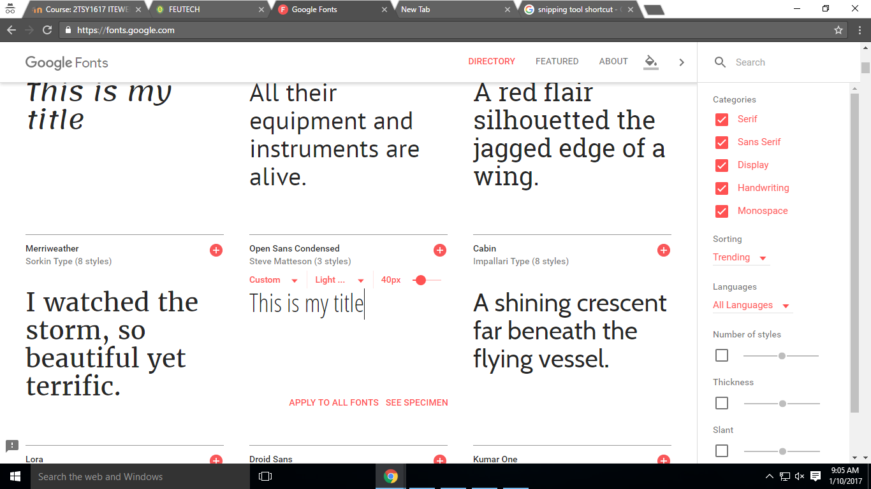*Ex.*

1. Background *(solid color, texture or image)*
2. Inspirations *(include screenshot of your design/website reference)*
3. PROJECT OUTPUT
   1. Home *(screenshot of your home page )*
   2. About *(screenshot of your about page )*
   3. Products/Services *(screenshot of products and services page/ please include description for each )*
   4. Contact *(screenshot of contact page)*
   5. Domain Name / URL